New house on old site: "The boathouse has stood there for several generations. It tells a story.
A resonance between new and old was the idea behind the restoration of an old ryfylkeboathouse at Sokn.
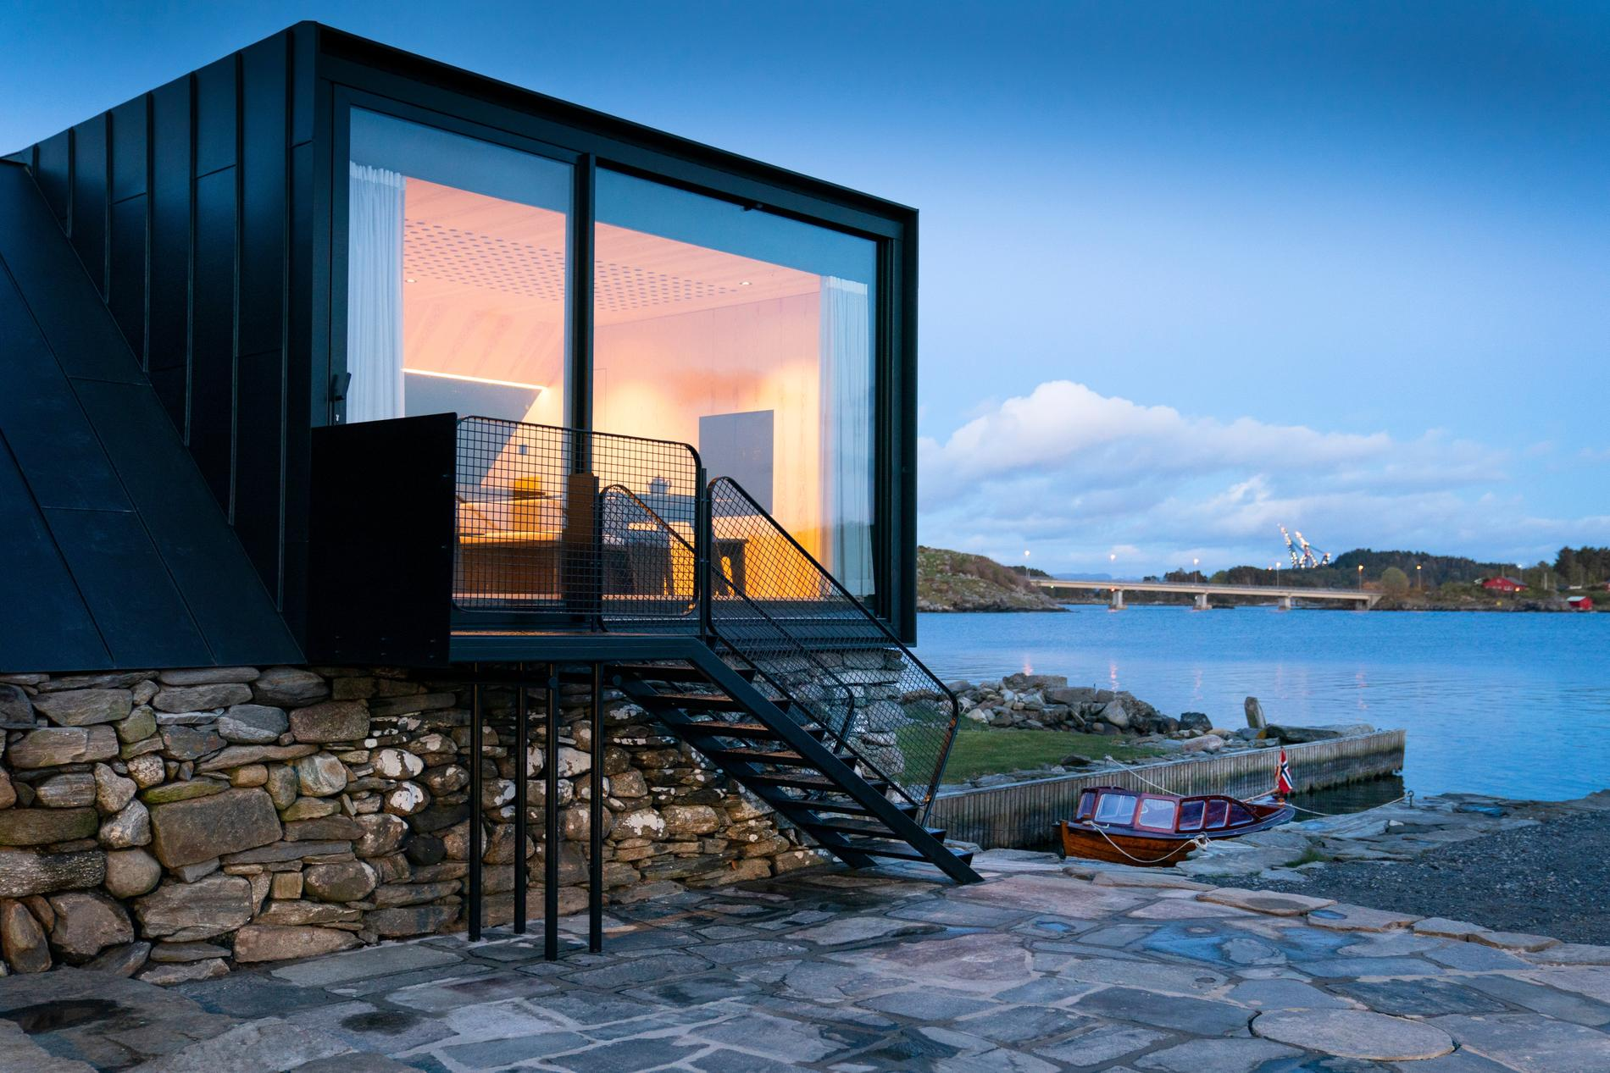A new building has been erected on the old boathouse walls on Rennesøy. The bridge and crane in the Åmøyfjord in the background tells a story about the oil age and new times. Photo: Fredrik Refvem

Hjørdis Irene Halleland Mikalsen
Published: May 24, 2020
Architect Espen Surnevik has always had a love for the historical. He was therefore not difficult to ask when he was asked to turn the 200-year-old boathouse site at Sokn into a modern holiday home. It tells a story. Not only about a building tradition that stretches back a thousand years, but also about a cultural heritage that is important to preserve. It fills me with great reverence.
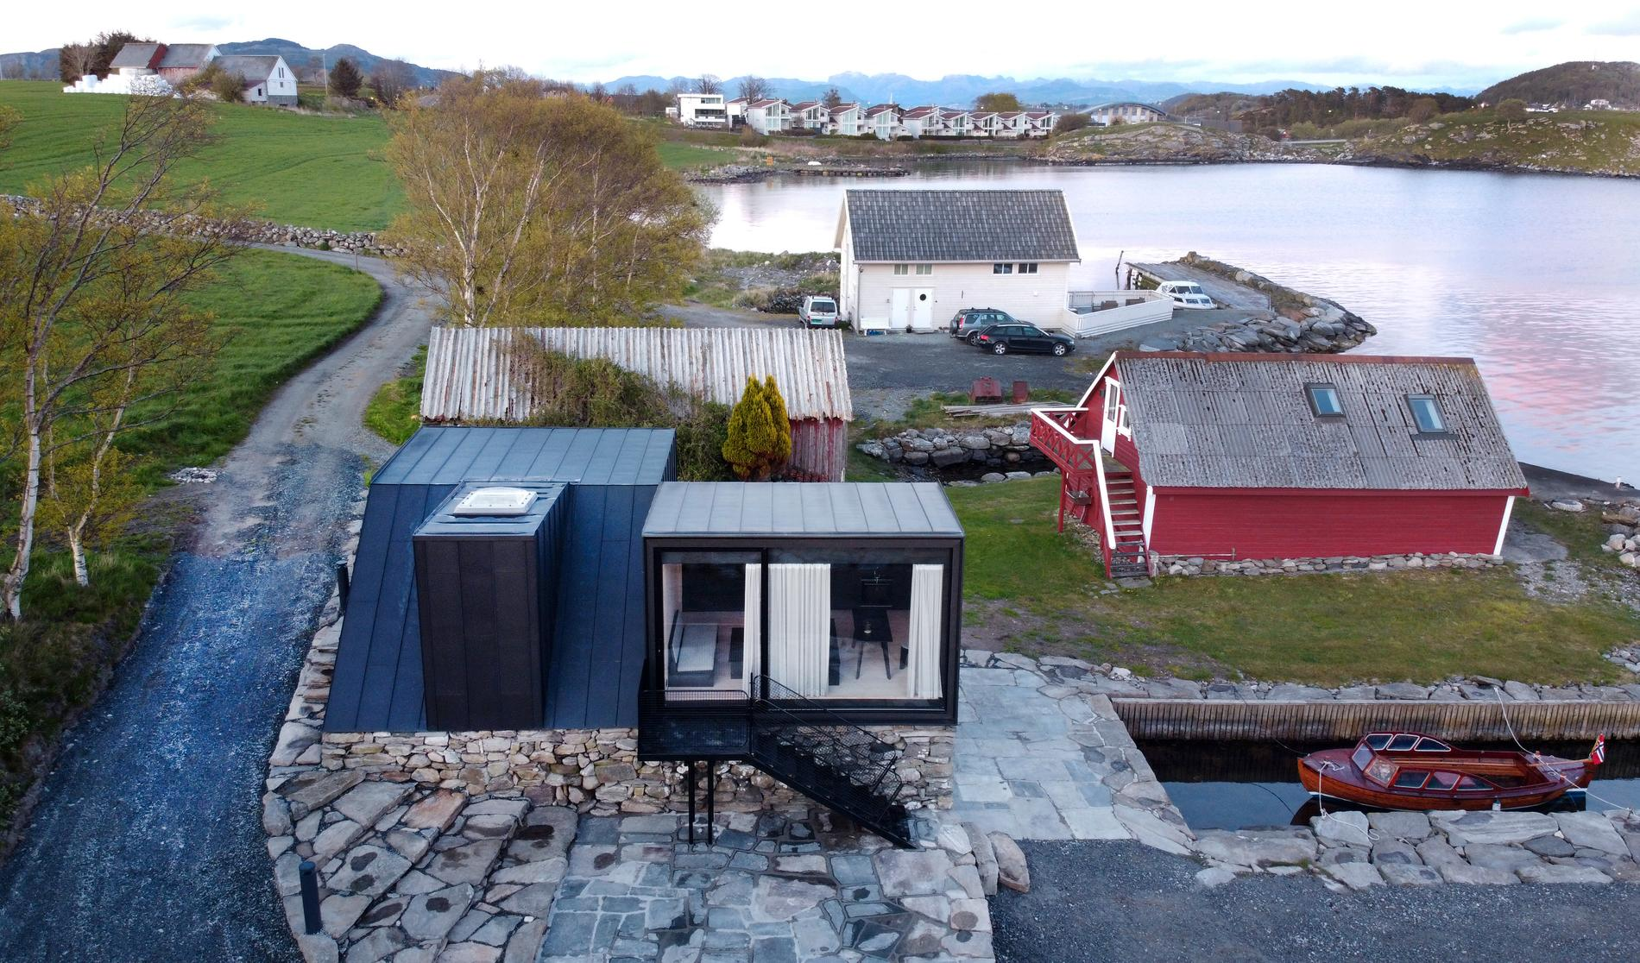Old and new side by side.Photo: Fredrik Refvem
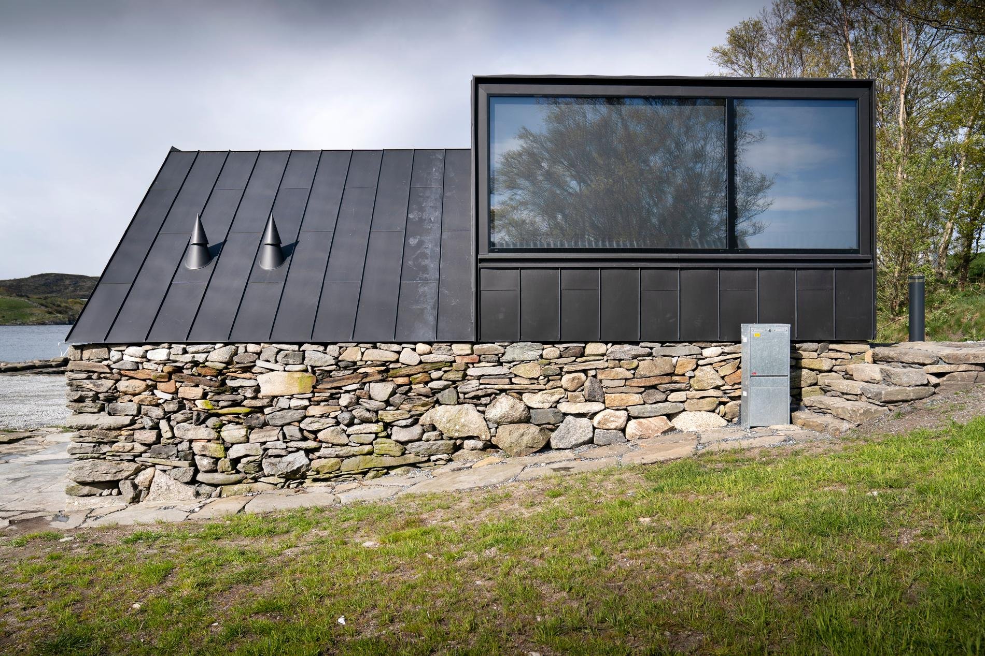The old foundations have been retained.Photo: Fredrik Refvem
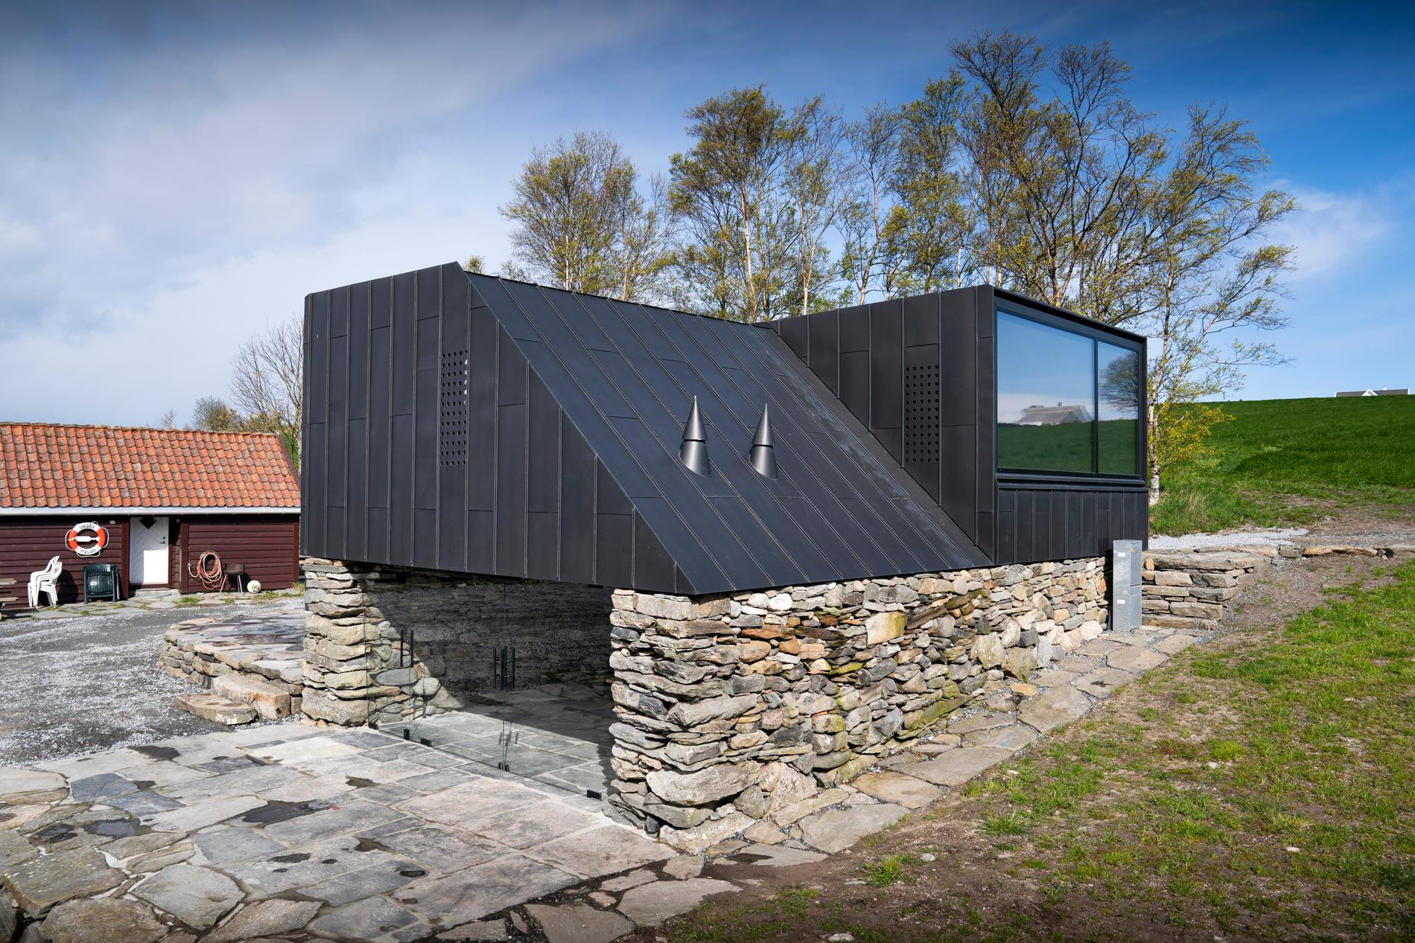As in the old boathouses, this does not have roof projections, but runs afoul of the old wall. The roof is made of oxidized zinc.Photo: Fredrik Refvem
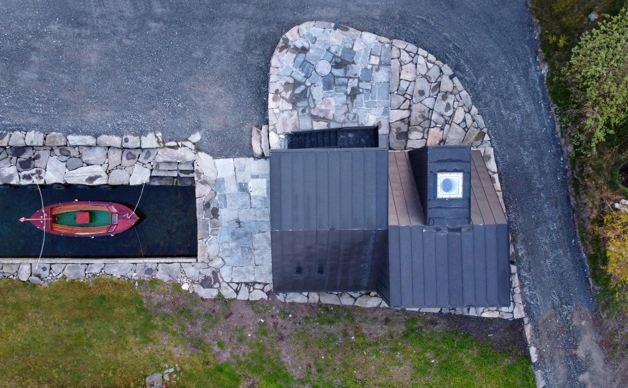The boathouse seen from the air.Photo: Fredrik Refvem
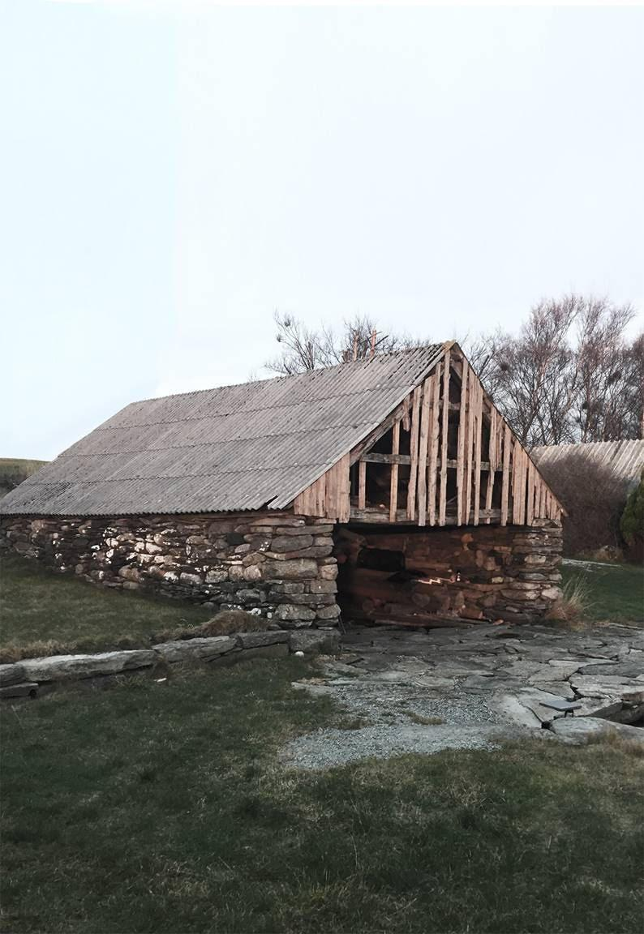The boathouse at Sokn was in a woeful condition before restoration started.Photo: Espen Surnevik
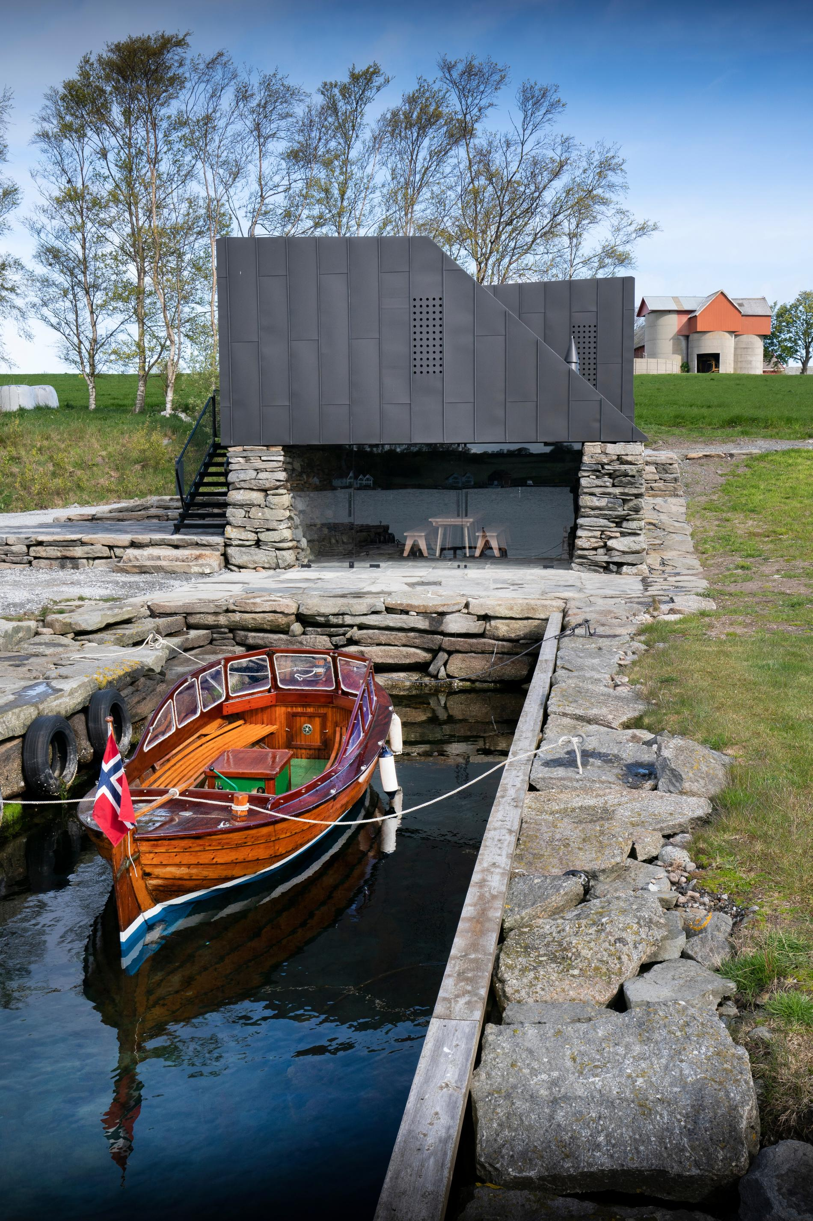The boathouse with the local barn in the background. Photo: Fredrik Refvem
The old Ryfylke boathouse is located in the beautiful cultural landscape of the island of Sokn in the new Stavanger municipality and is owned by farmer and former Rennesøy mayor Jostein Eiane.
The boathouse was in a deplorable condition. The superstructure was rotting away, but the beautiful natural stone wall was still intact. Eiane wanted to give the old boathouse new life. He contacted architect Espen Surnevik, who has roots in Rennesøy.

Award winning
Espen Surnevik was born and raised in Våland, the youngest of four siblings and the son of former Aftenbladet editor Per Surnevik. Surnevik was still in lower secondary school when her parents decided to move to the family farm on Rennesøy. Thus, he joined the move.
"It was a big transition for a city boy from Våland to move to the country. But it was on Rennesøy that I discovered architecture and old building traditions," he says.
Today he lives in Oslo where he runs a one-man architectural office in addition to his position as professor at the Department of Architecture at the School of Architecture.
"In this way, I get to work in the intersection between academy and practice. A combination I really enjoy," he says.
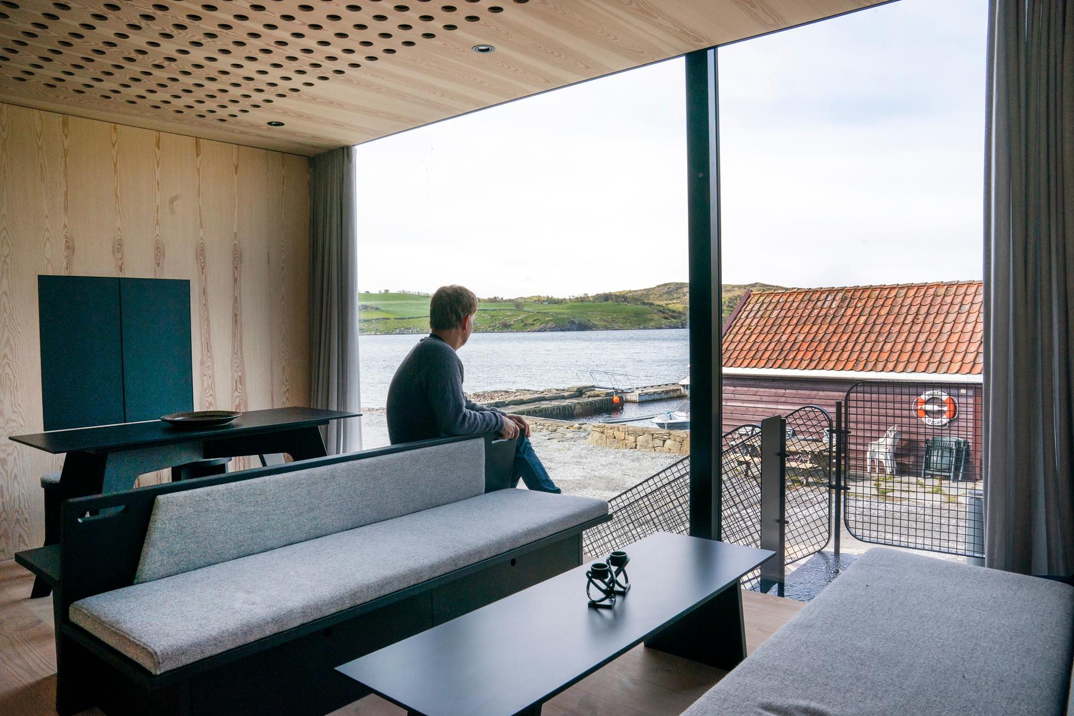Jostein Eiane enjoys the view over to Bru. The black cabinet on the wall camouflages a television set and other electronics.Photo: Fredrik Refvem
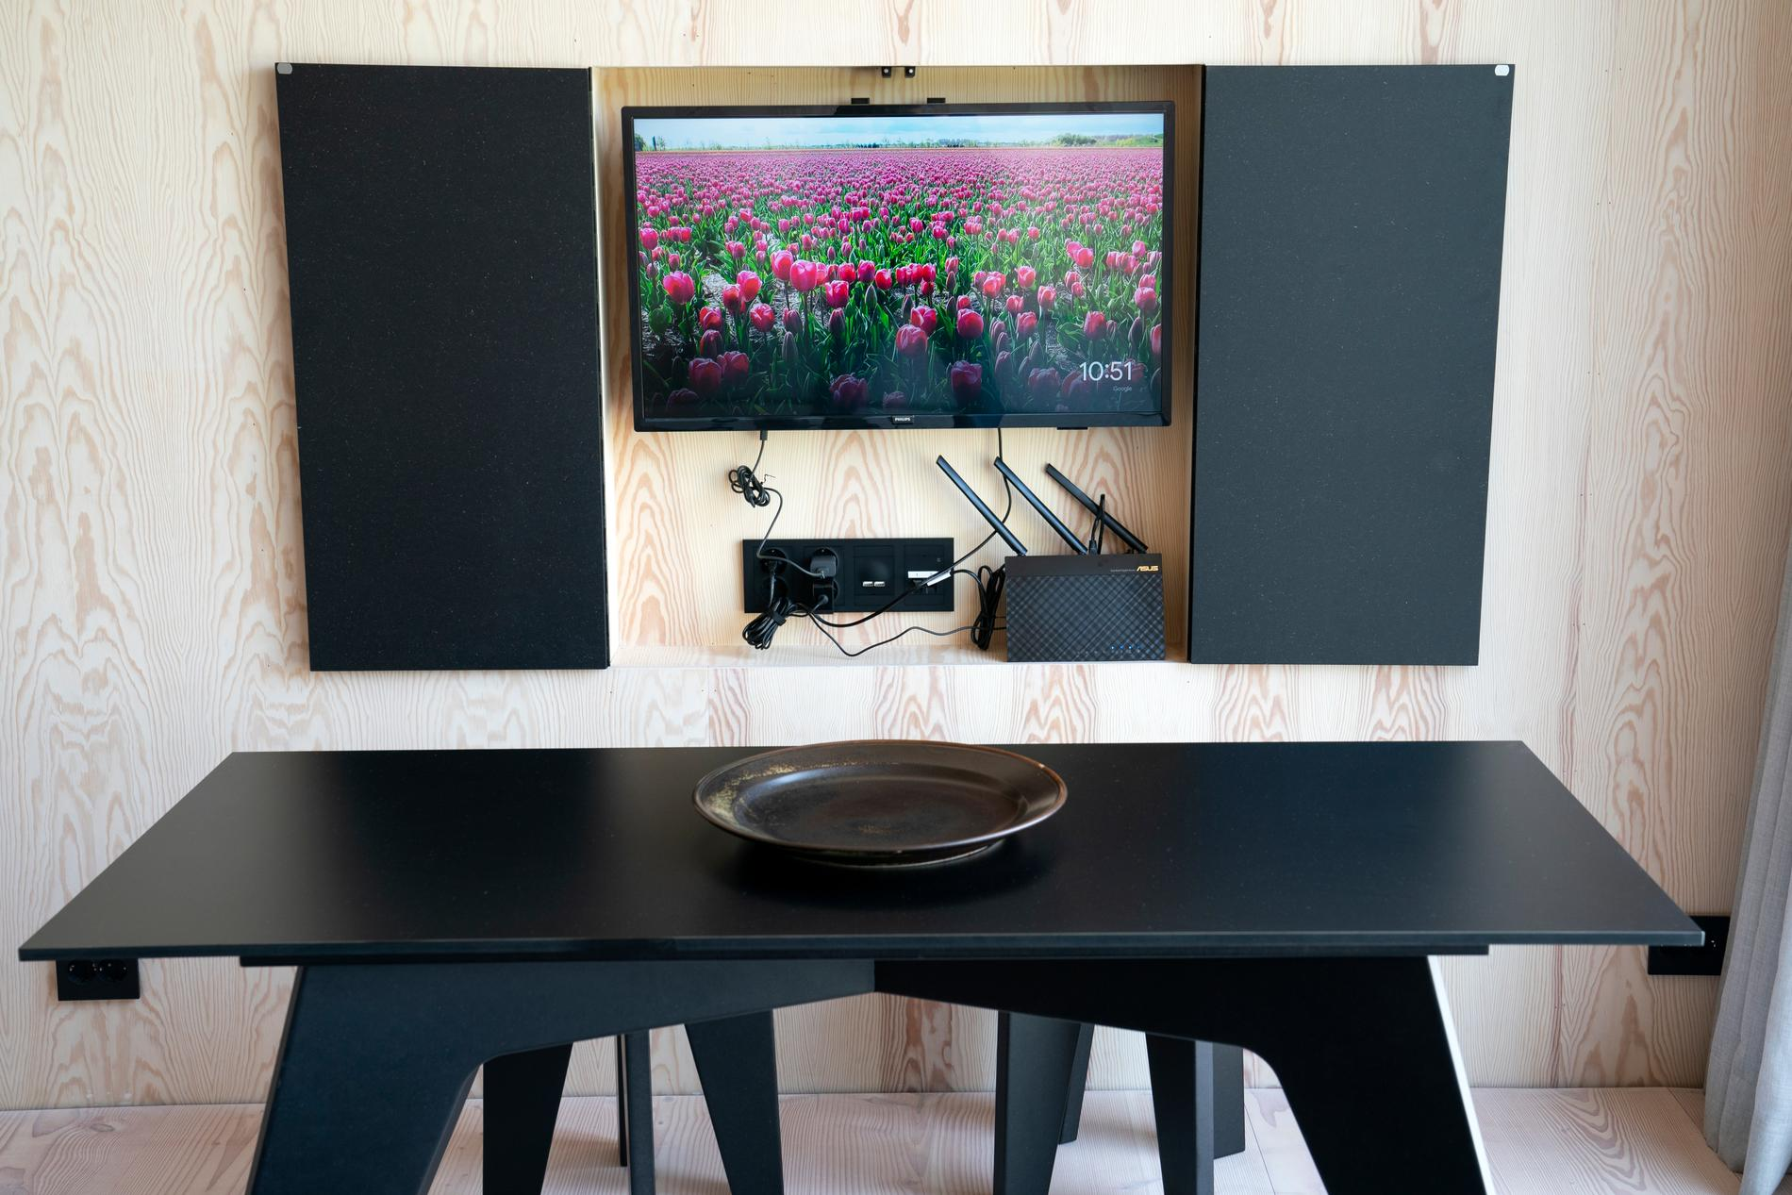The TV is hidden in the wall. Photo: Fredrik Refvem
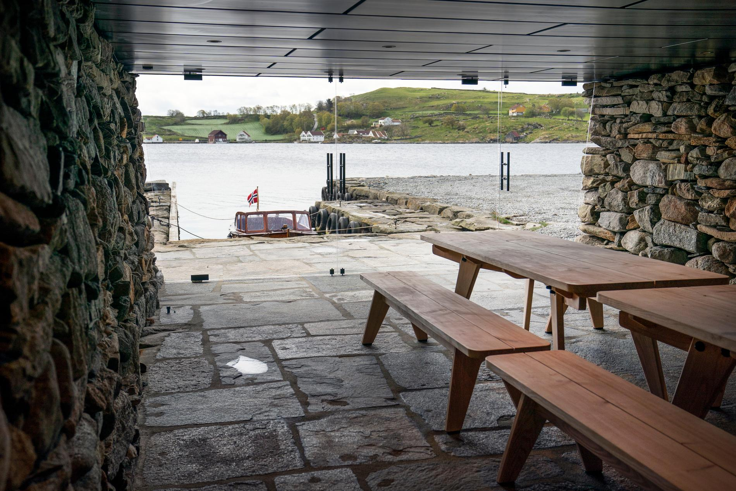When work on the renovation of the boathouse started, this was a room with a dirt floor. Now it has got slate floors with heating cables and pine furniture that can withstand the flovage entering the room. The view over to the Bridge is impeccable.Photo: Fredrik Refvem
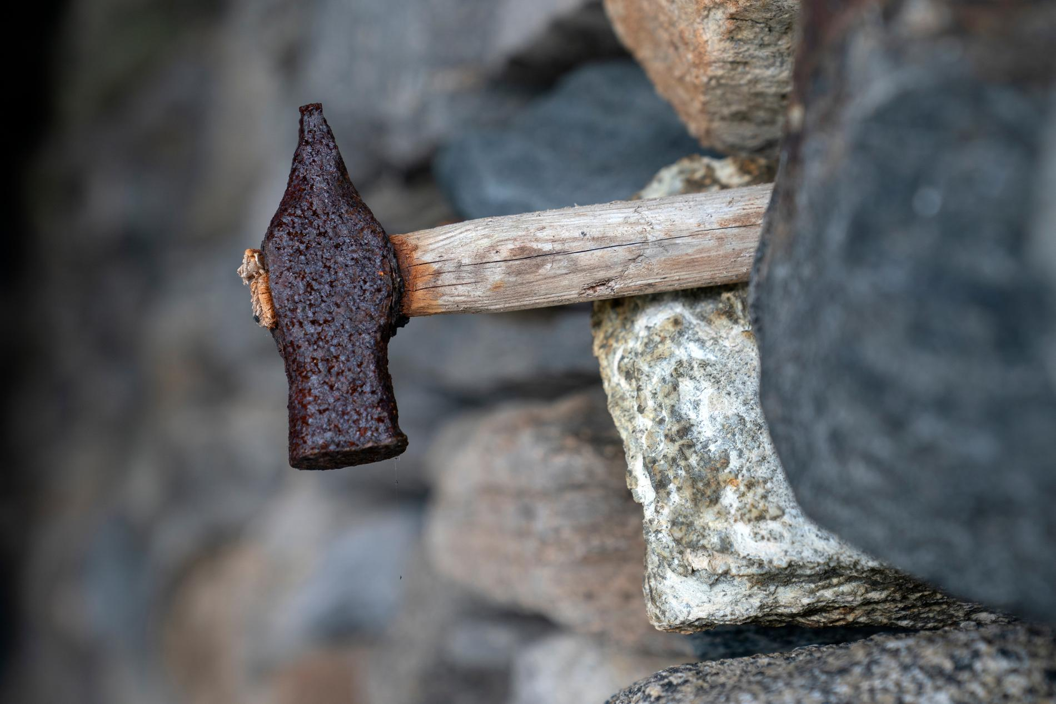Seeing tools wedged into the brick wall is not uncommon in old boathouses. This hammer may have stood for 100 years, and it should still be allowed to stand.Photo: Fredrik Refvem
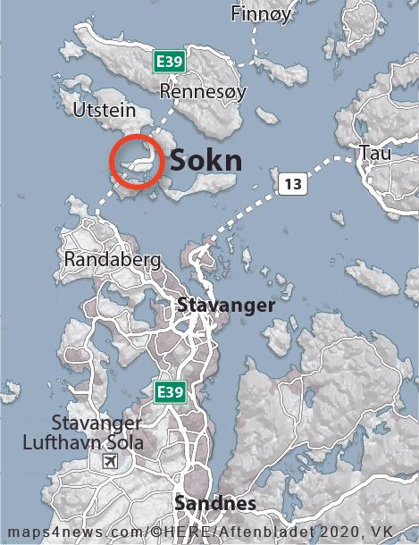

Application

The island is 1.31 square kilometres in size and is located in Stavanger municipality.
The highest point is Hodnet, 22 meters above sea level.
Soknasundet between Sokn and Bru is the place where Aslak Fitjaskalle "cut Norway off Olav Haraldsson's hands", according to Snorre. Two years later, revenge came on Stiklestad.
Source: Wikipedia

Follows the whole process
Surnevik works throughout with the projects and is responsible for all phases of architectural and landscape design.
"I follow the entire process from the first sketches until the entire building is completed," says the architect, who has received several awards for his work.
He received the best in 2016, when he was awarded the Norwegian Award for Building Design for Våler Church in Solør.
"It was great. I was the first individual to receive this award, which usually goes to major architectural firms," says Surnevik.
He was also the main architect for Østre Porsgrunn church in Telemark. Also for this construction project, Surnevik won a kind of "prize", namely the Christian daily newspaper Today's award of Norway's ugliest church.
"I take that with crushing calm," the architect says with a chuckle.
"We are talking about a poll with almost 900 votes on Facebook. In addition, Dagen is a newspaper originating from the Christian prayer house movement, which traditionally has a negative view of Norwegian church culture. So no, I haven't lost sleep for that reason.
He would much rather talk about his newest project: the old boathouse sites at Sokn.
The boathouse's "master bedroom" is not large, but well utilized. There is access to the room via two sliding doors, one on each side of the bed.Photo: Fredrik Refvem

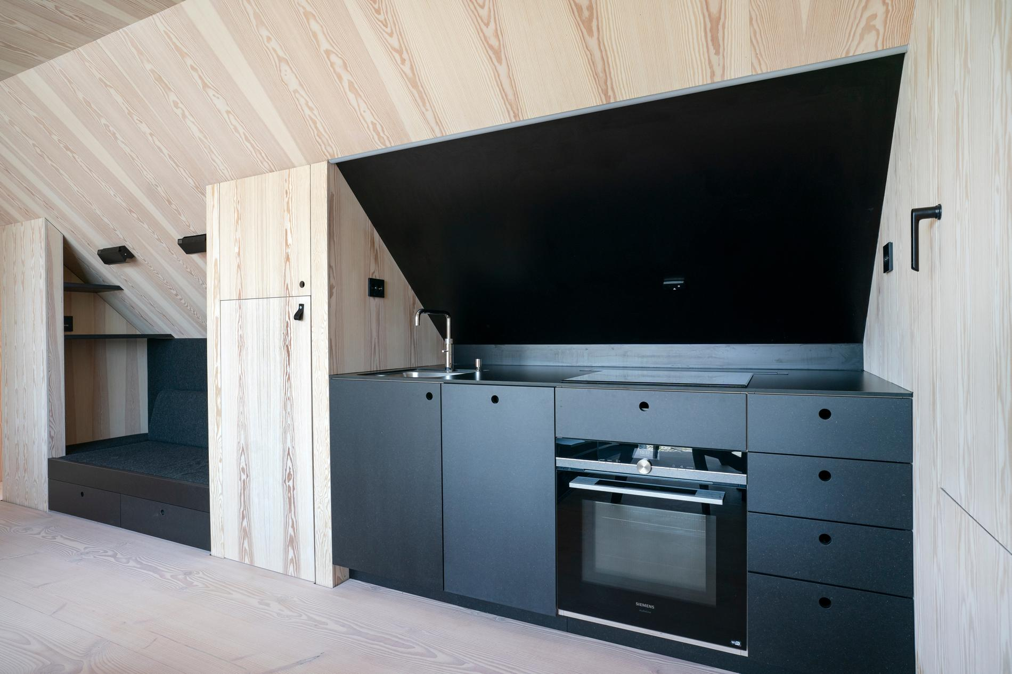The kitchen was also designed by Surnevik. The black wall is in the same material as the worktop. Thus, it is easy to clean from grease and food splashes.Photo: Fredrik Refvem
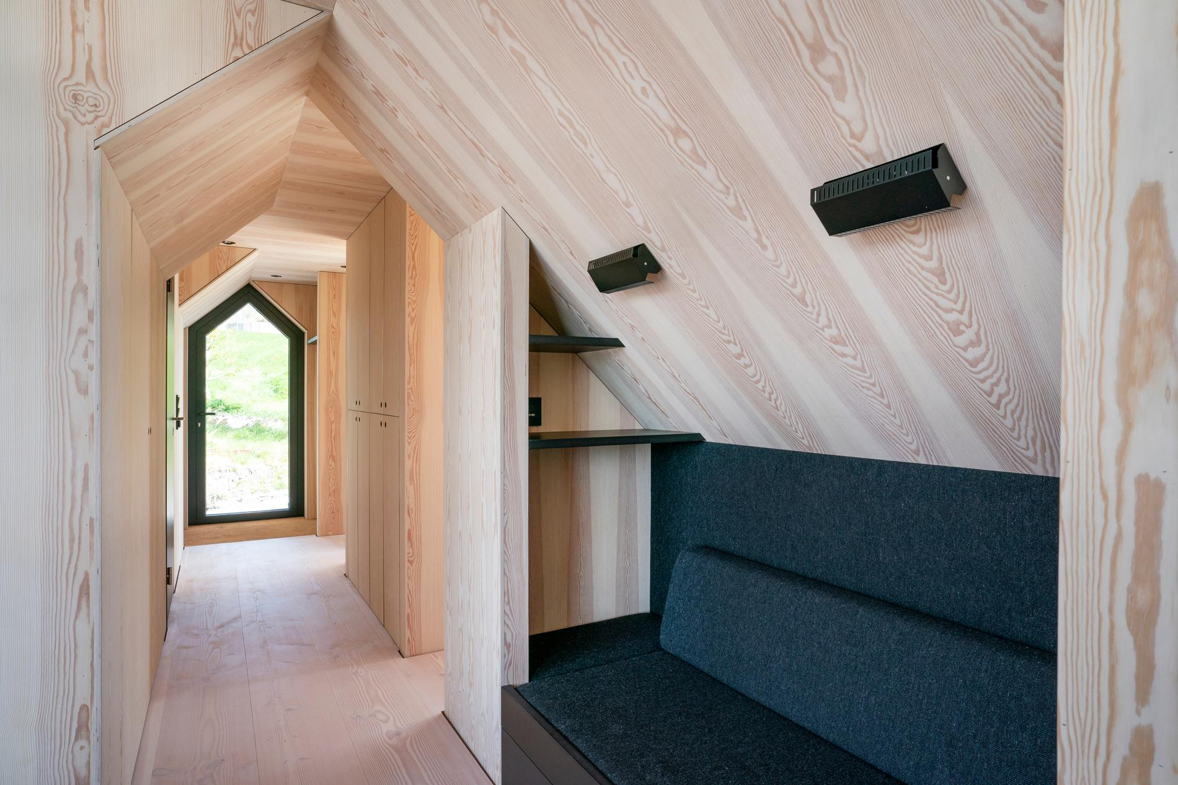This site-built sofa is a cosy place for quiet reading moments and can easily be converted into an extra sleeping space. It also has convenient storage in large drawers.Photo: Fredrik Refvem
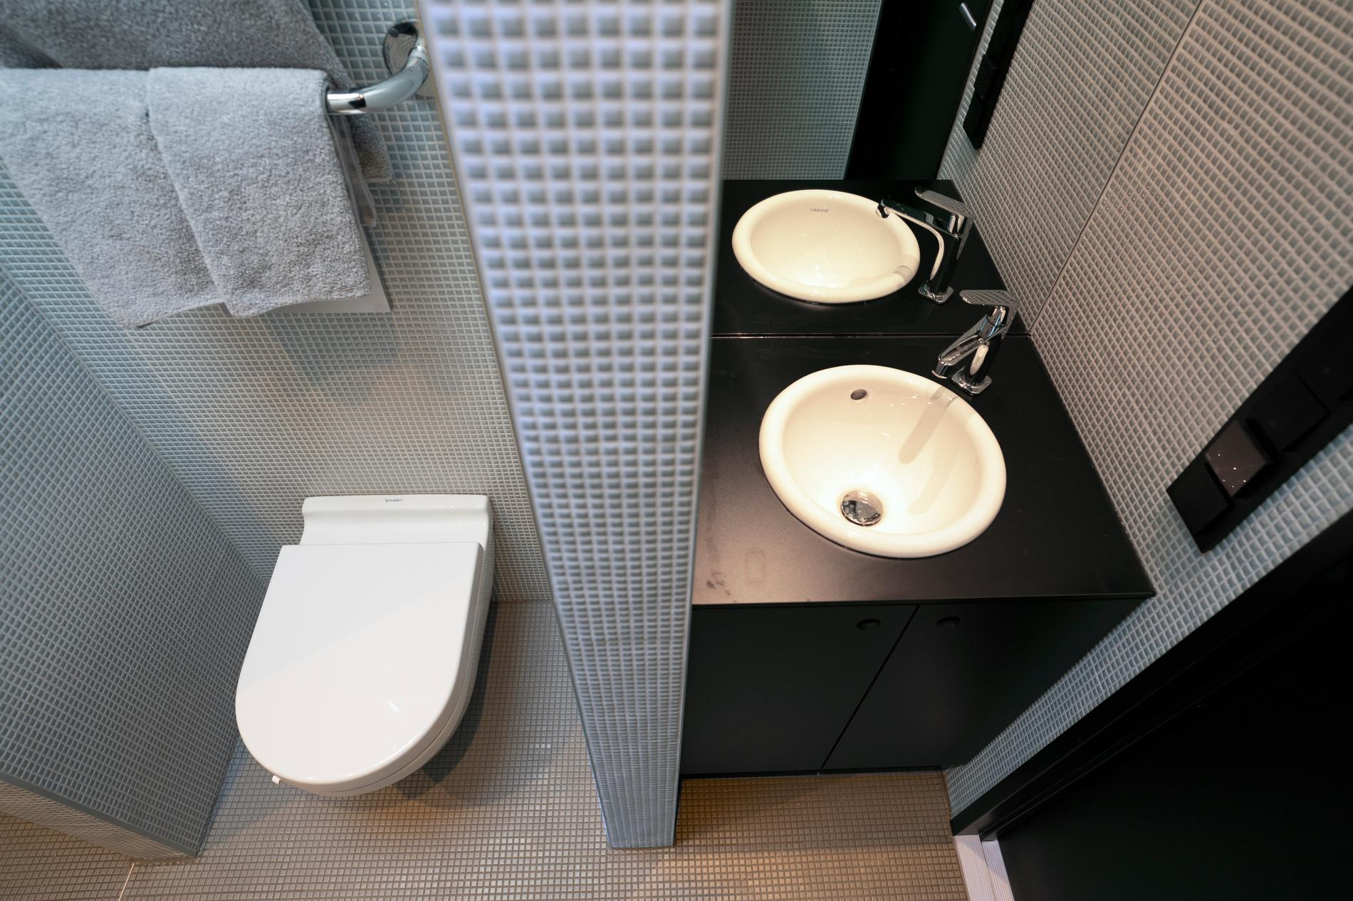The bathroom of around 3 square meters consists of three niches: one for shower, one for toilet and one for sink. Photo: Fredrik Refvem

Old and new
The boathouse project started in 2017.
"It's taken three years, which is typical of my projects. I work slowly, both because I run for myself in addition to teaching at the School of Architecture, but also because I enjoy letting the projects mature during the construction process.
The original superstructure has been replaced with a modern structure of oxidized zinc in black, matte colour.
"What I like most about this project is the unison between the old stone walls and the new zinc cladding. The dark surface complements the infinite shades of grey found in the ancient natural stone walls. It provides a readable dialogue between the past and the future," says the architect enthusiastically.
The boathouse had dirt floors that have now been replaced with slate slabs over heating cables.
"This will be a kind of combi room that can be used to store both boat and fishing equipment, which was also the room's original function. In addition, it is a nice place to set long tables and invite to crab teams or a barbecue.
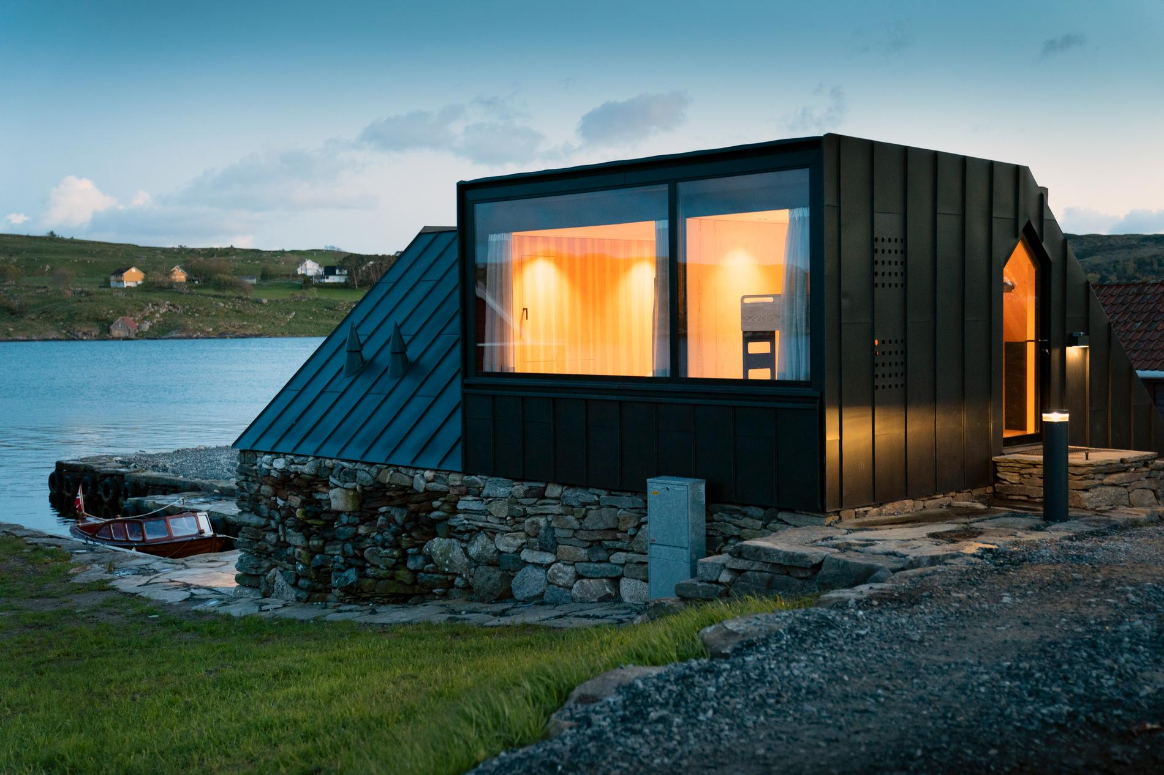The light bollard and the soft light from the bedroom windows and front door make for an inviting image at dusk.Photo: Fredrik Refvem
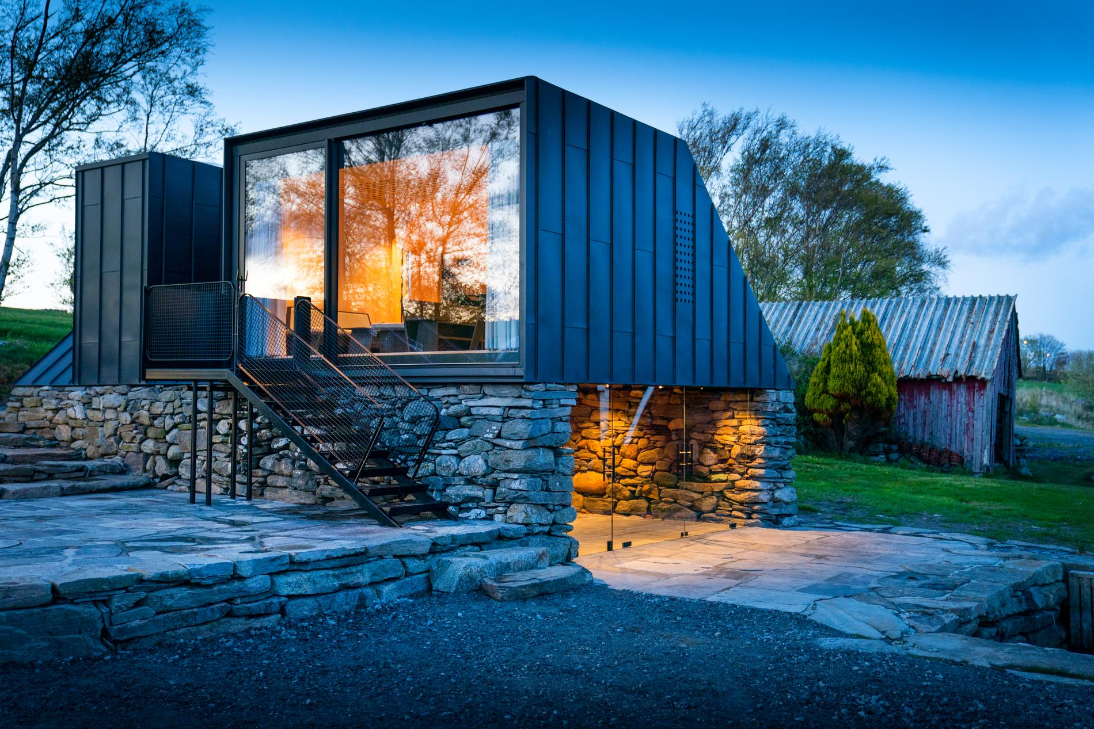As darkness descends, the glass doors come into their own. The contrasts with the neighboring boathouse tell a story of the present and past.Photo: Fredrik Refvem
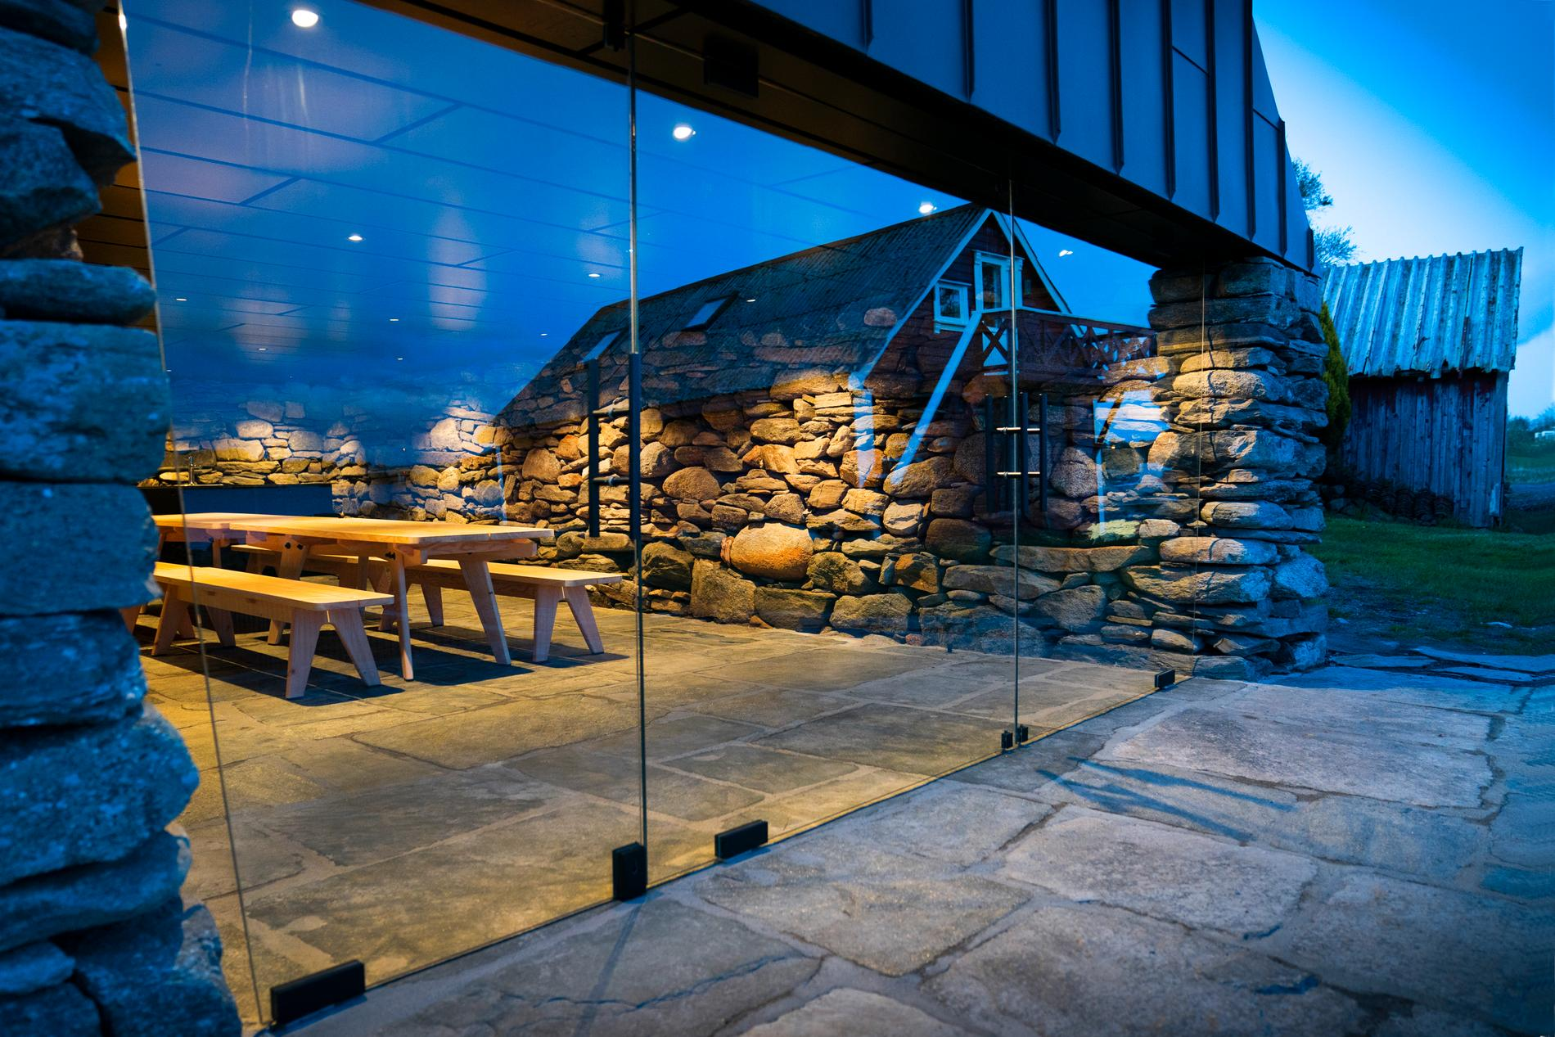The doors are in tempered glass.Photo: Fredrik Refvem
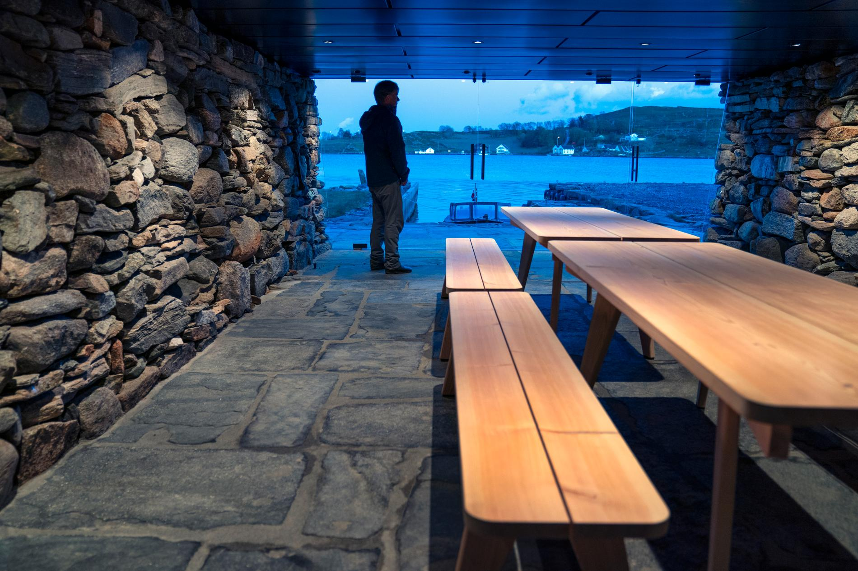Jostein Eiane enjoys the blue hour and the view over to Bru. Surnevik designed the furniture, and they were made by HøieUeland, who also carried out the construction work otherwise. The furniture is made of solid pine and can withstand flooding "on your feet". Photo: Fredrik Refvem
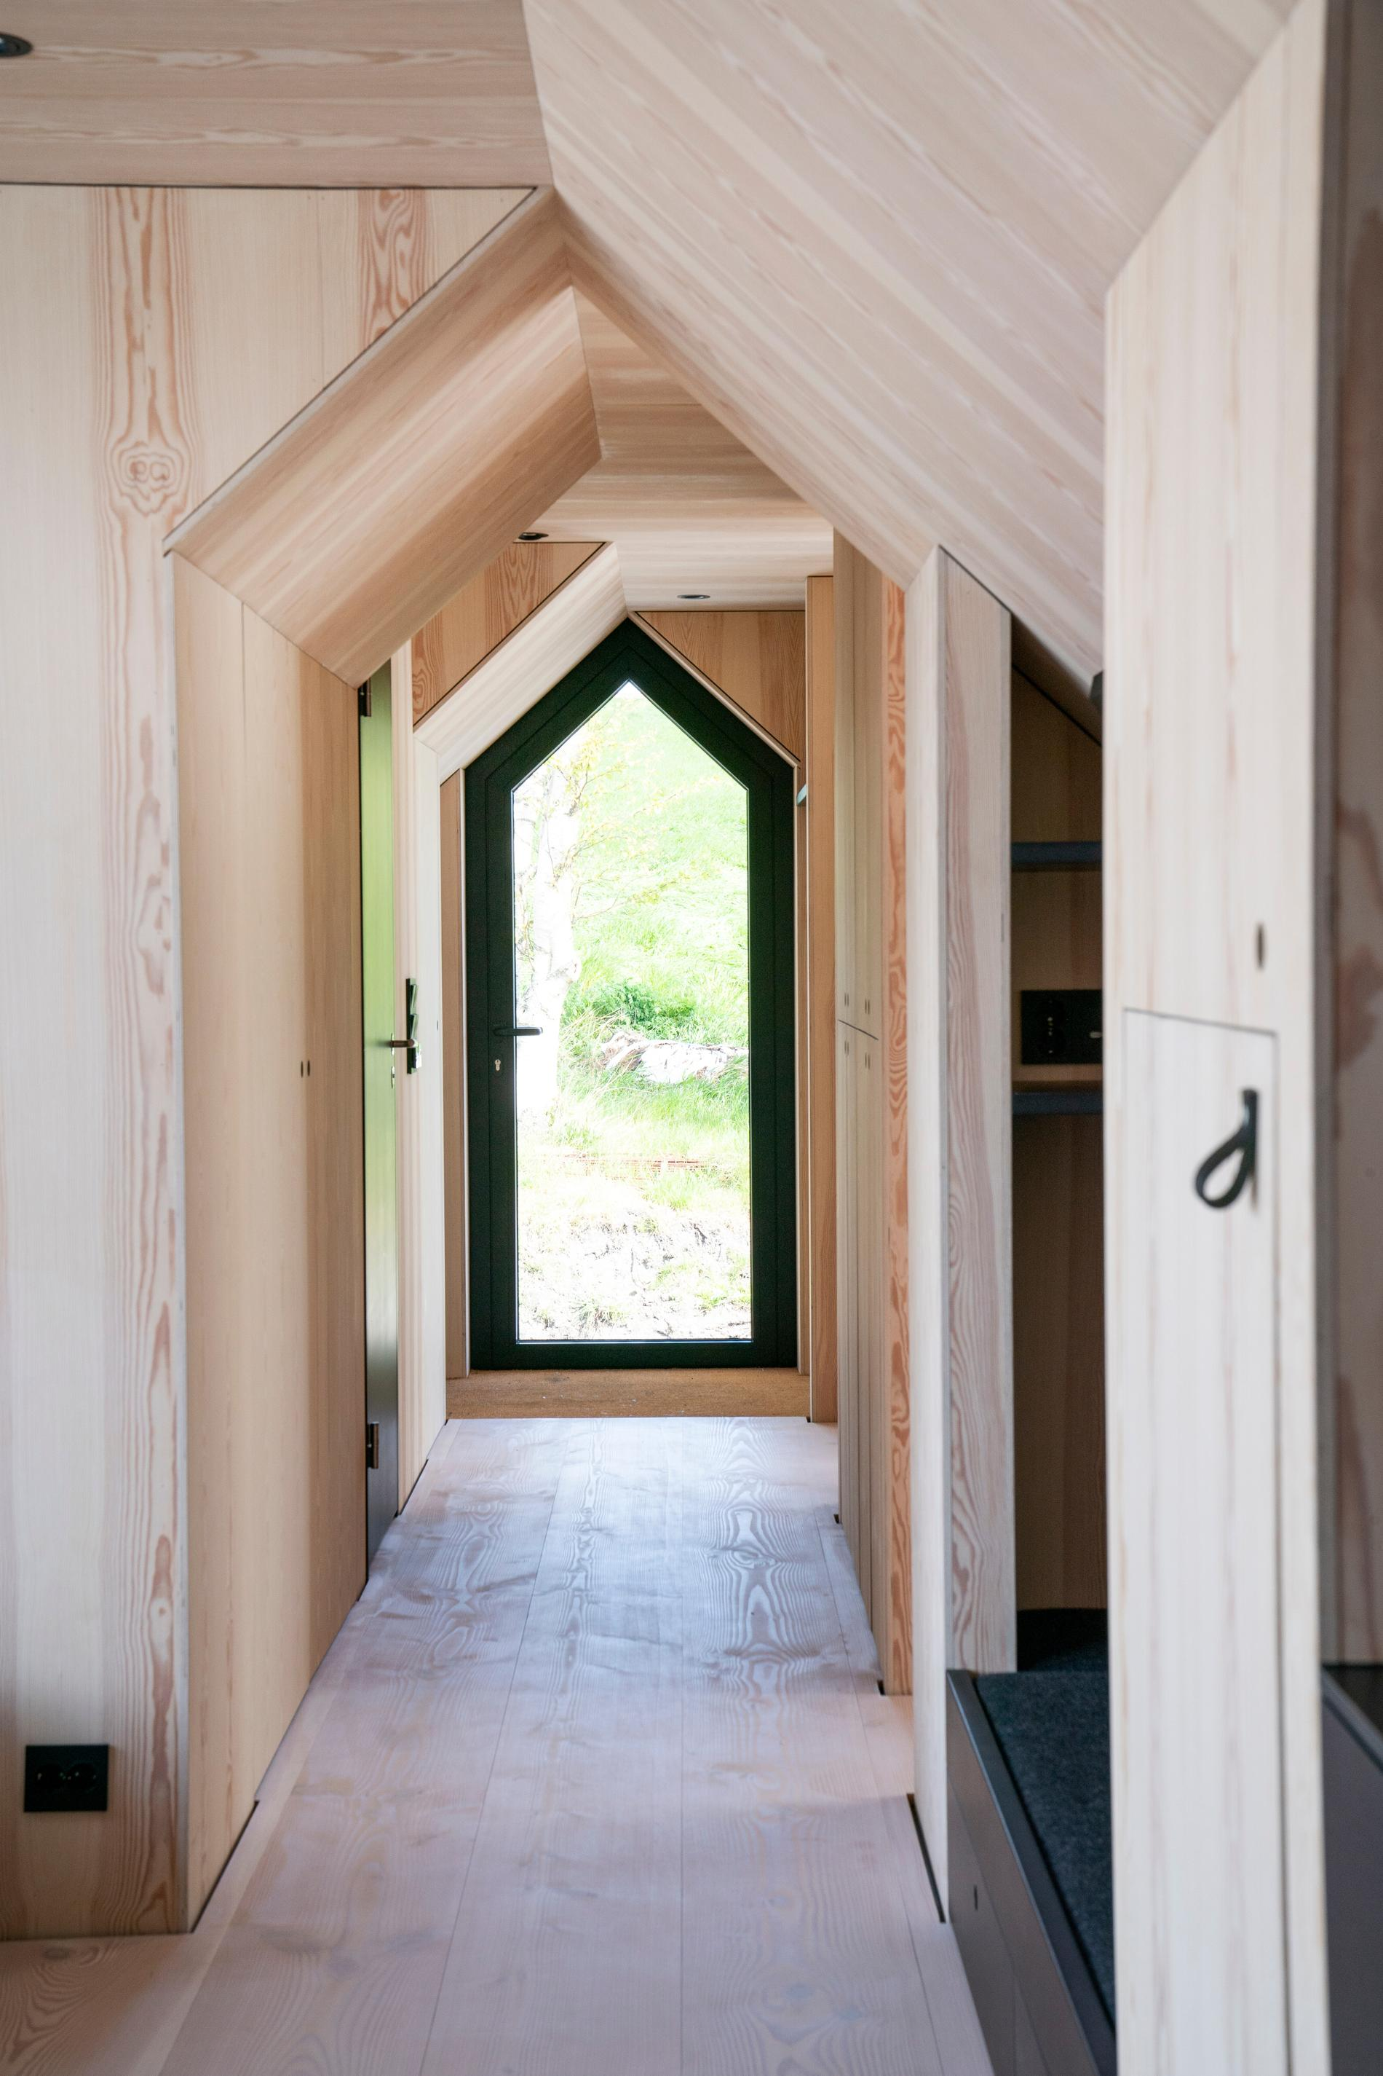The interior geometry reflects the exterior, in the hallway leading to the boathouse's two bedrooms, bathroom and exit door.Photo: Fredrik Refvem
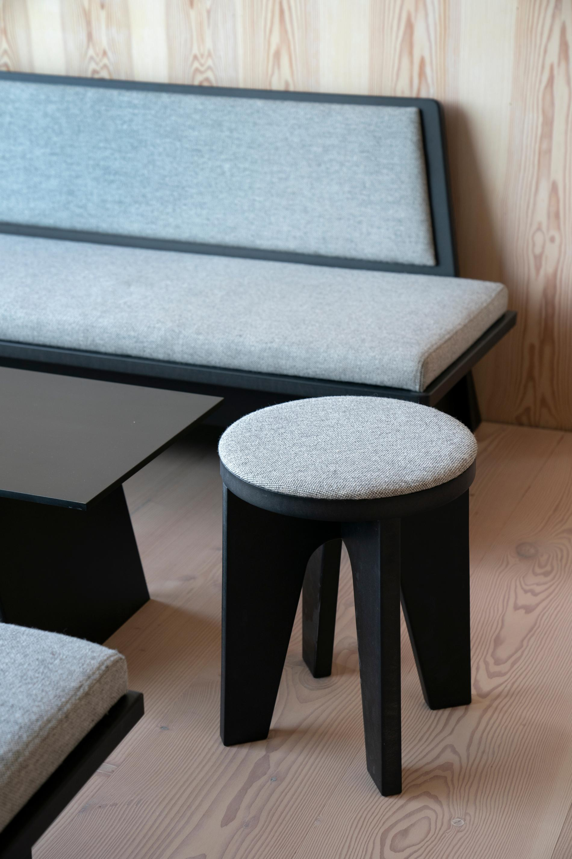The furniture in the boathouse is specially designed by the architect himself and made of black MDF and wool fabric in the same shade as the sheep outside the boathouse windows.Photo: Fredrik Refvem
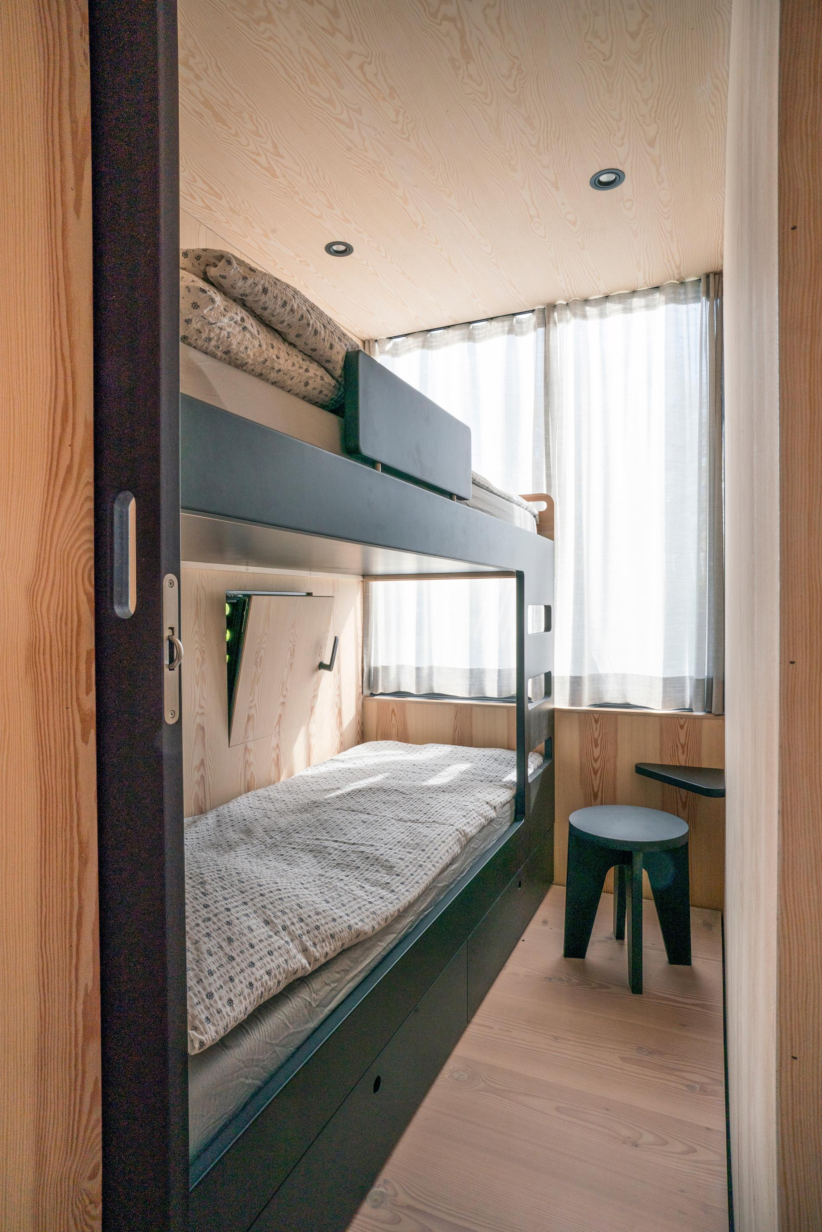The bunk beds are purpose-built, with separate air hatches to let in the soothing sea air outside.Photo: Fredrik Refvem
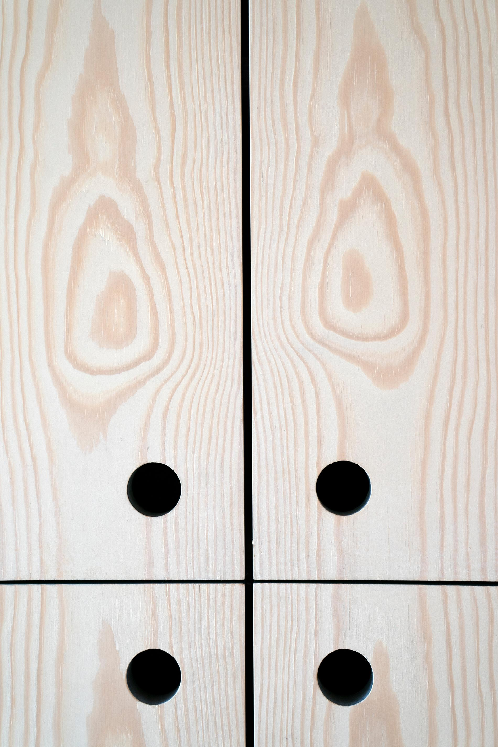Built-in cabinet doors in pine veneer and "black holes" to open with.Photo: Fredrik Refvem

Modern
An external staircase leads up to the new superstructure of around 60 square meters. A modern and functional living area with living room, kitchen, bathroom, storage room and two bedrooms. Large windows face the sea. The walls and ceiling are sheathed with pine.
"This choice of material alludes to earlier times, when solid pine timber was often used when boathouses were to be built.
Together with Eiane, he had to plan the rebuilding carefully in order for it to be approved.
"An important argument in the application was precisely that we expressed a clear desire to preserve the old site, in addition to copying the boathouse's original geometry," explains Surnevik.

Something unique
The owner's plans for the house are to rent out to summer guests.
– Now we are facing an uncertain summer due to the corona outbreak, at the same time we are encouraged to holiday in Norway. Then Sokn is a great destination, says Eiane.
Sometimes he takes a walk downstairs just to feel the atmosphere.
"Espen Surnevik has managed to turn the boathouse into something unique. It has something about it that must be experienced, especially because it has different expressions at different times of the day. During the day it has its own way of capturing the light, and in the evening, when it is dark outside and bright inside, the atmosphere is warm and the walls really come into their own.
Published: May 24, 2020 09:00 AM

